Friday finally rolled around, which meant no drama rehearsal for Charlotte and no basketball for Mateo. After school the three of us coasted the long downhill to my house, skidded into the gravel driveway, dumped our bikes, and sprinted up the stairs two at a time.
I’d cleaned it as much as a human can reasonably clean a seventh grader’s room—which is to say, the dirty socks were at least all in the same corner. On my desk I had the circuit I made at Grandpa’s.
“Okay,” I said, grinning as they crowded around. “This is what Grandpa and I built after school yesterday. He showed me how to hook up the Arduino and write code to make one LED blink.” I plugged the Arduino into the computer to give it power, and the tiny light began a steady on-off rhythm.
Mateo’s eyebrows went up. “That’s…actually kind of cool.”
Charlotte leaned in, hands on her knees. “It’s like a little robot heartbeat.”
“Exactly,” I said. “But here’s the deal—Grandpa says that before he’ll teach us how to build an actual moving robot, we have to make a traffic light. Three LEDs, wired to different pins, and cycling in the right order. He calls it ‘earning your green light.’”
Mateo straightened up, eyes wide. “Hey—that’s what Marvin Marindale wants us to do too!”
Charlotte gave him a sideways look. “Do you think that’s weird? I think that’s kind of weird. This eccentric billionaire left a mysterious scavenger hunt that we’ve stumbled into and his assignment to us is what we were going to do anyway.”
“I don’t care if it’s weird or normal,” I said. “Either way—red, yellow, green—it’s happening tonight.”
We worked on the circuit for the next few minutes, guessing how we might set it up. Here’s what we did:
(show sketch)
Note that we’ve wired it this way:
Pin 13 to the red LED
Pin 12 to the yellow LED
Pin 11 to the green LED
All LED’s back to the GND pin via the negative column on the breadboard.
“We just need to program it now,” I said.
We opened the Arduino IDE and looked at the first lines of code in our current program:
void setup() {
// set pin 13 as an output:
pinMode(13, OUTPUT);
}

“We need to do this, but for all three pins that we’re using,” I said.
We wrote it like this:

void setup() {
// set pins 13, 12, 11 as outputs:
pinMode(13, OUTPUT);
pinMode(12, OUTPUT);
pinMode(11, OUTPUT);
}

“I get it!” said Charlotte. “This void setup part of the program is where you setup the microcontroller.”
“That’s right,” I said. “And the next part is where you tell it what to do.”
Here’s what our old program said:

void loop() {
// turn the LED on
digitalWrite(13, HIGH);
delay(1000); // wait for one second

// turn the LED off
digitalWrite(13, LOW);
delay(1000); // wait for one second
}

“We turn it on and then the program pauses for one second,” I said.
“And then we turn it off and pause for one second again,” said Charlotte.
“And we repeat those two steps over and over,” said Mateo. “That’s why they’re in the ‘loop.’”
“I have a question, though,” said Charlotte. “Why do we say high when we mean on and low when we mean off?”
“I don’t know,” I said.
“We just need to do this for all three LED’s, right?” said Mateo.
“Let’s do it,” I said.
Here’s the whole program we wrote:
(insert screenshot)
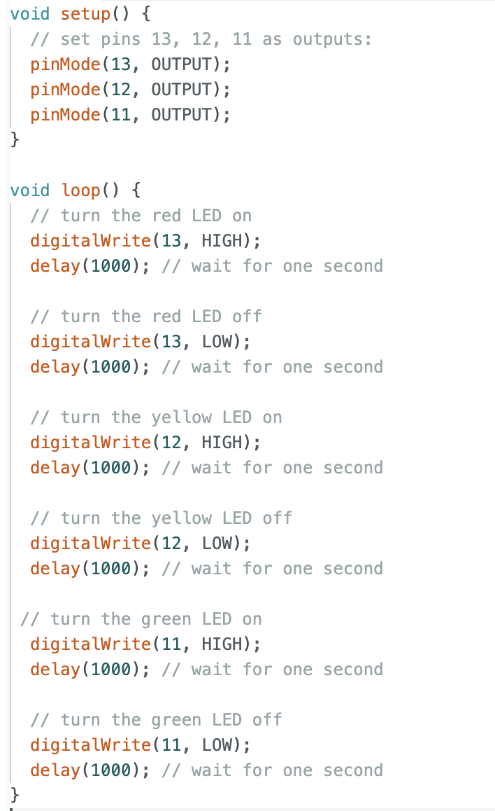
Guess what.
It worked.
(show sketch)
Or I should say…kind of worked.
It wasn’t really like a traffic light. The red would come on then go off, then no light would be on for a second before yellow came on.
But we figured out how to fix that. Can you?
Here’s your challenge.
Write a program that
- makes the green LED light up for 5 seconds
- then the instant the green LED turns off, the yellow LED comes on, and stays on for 2 seconds
- then the instant the yellow LED turns off, the red comes on, and stays on for five seconds.
- and the whole sequences loops back to the beginning and does it over and over again.
Good luck!

As you can see, it’s totally possible to write a computer program without knowing what everything means. People do it all the time! But if you want to know why HIGH means ON and LOW means OFF, go to here (web site address)

